**COS10004: Computer Systems**

**Lab 1**

**Name: SWH00420 Tran Quoc Dung**

**Student ID: 103803891**

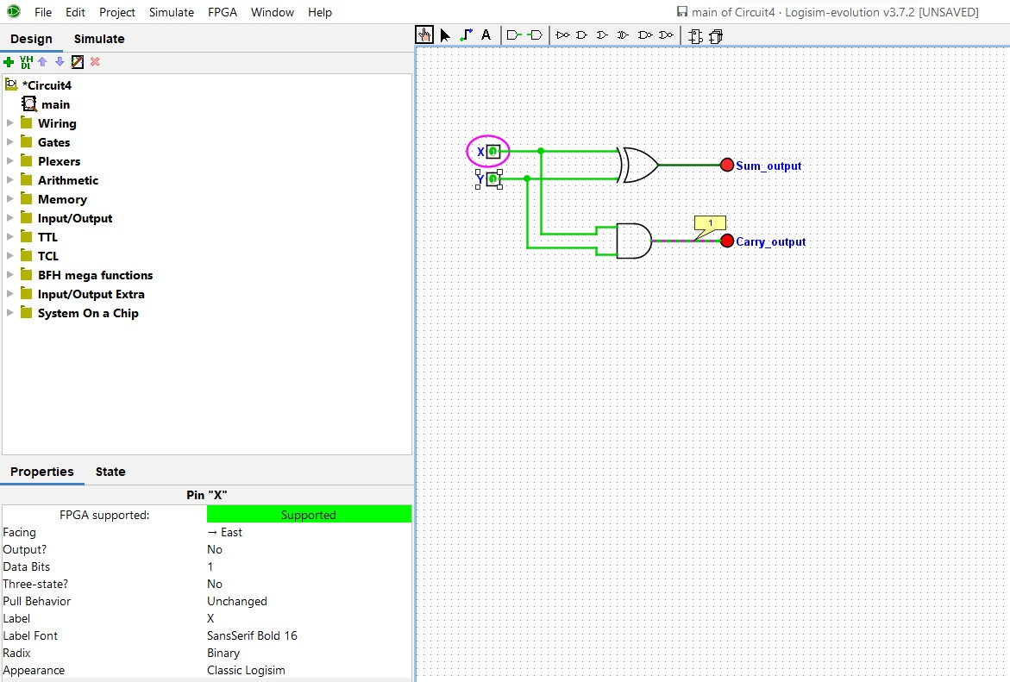

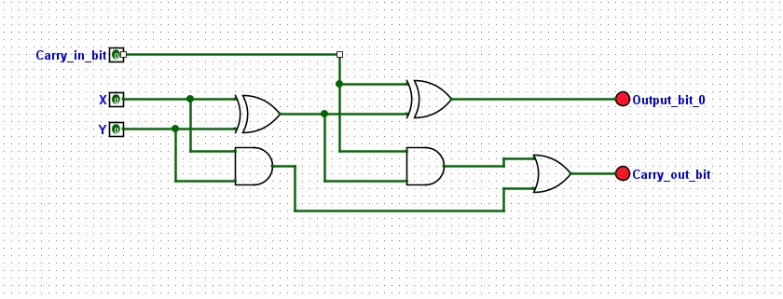

|  |  |  |  |  |
| --- | --- | --- | --- | --- |
| **Input 1** | **Input 2** | **Carry In** | **Sum Output** | **Carry Output** |
| 0 | 0 | 0 | 0 | 0 |
| 0 | 1 | 0 | 1 | 0 |
| 1 | 0 | 0 | 1 | 0 |
| 1 | 1 | 0 | 0 | 1 |
| 0 | 0 | 1 | 1 | 0 |
| 0 | 1 | 1 | 0 | 1 |
| 1 | 0 | 1 | 0 | 1 |
| 1 | 1 | 1 | 1 | 1 |

**Circuit 5**